Anty-Bullying Policy

Політика проти цькування
Effective from: 22 February 2024
Review date: 04 October 2025
Contents
Key Contact Personnel 3
Introduction 3
Policy objectives 3
Links with other school policies and practices 3
Legislative Framework 4
Responsibilities 4
Definition of bullying 4
Types of Bullying 5
School ethos 5
Responding to bullying 5
When bullying is reported: 5
Cyberbullying 6
The school will: 6
Supporting Pupils 6
Pupils who have bullied others will be supported to: 6
Supporting adults 6
Adults who are bullied will: 6
Adults who have perpetrated the bullying will be helped by: 7
Preventing bullying 7
Involvement of students 7
Involvement with parents and carers 7
Monitoring and review 8
Useful links and supporting organisations 9
SEND 9
Cyberbullying 9
Race, religion and nationality 10
LGBT 10
Sexual harassment and sexual bullying 10
o A Guide for Schools: 10
References 10
Appendix: Anty-bullying flowchart 12

Key Contact Personnel
Nominated Member of Leadership Staff Responsible for the Policy: Dr Alexandra Sevko, Headteacher.
Designated Safeguarding Lead (DSL): Iryna (Ira) Shymkova, Deputy Headteacher.

Introduction
This policy is based on on statutory and non-statutory guidance including: DfE Preventing and Tackling Bullying (2017), DfE Keeping Children Safe in Education (KCSIE, 2025), DfE Sexual violence and sexual harassment between children in schools and colleges (2021), Childnet’s Cyberbullying: Understand, Prevent and Respond: Guidance for Schools (2016). Reading Ukrainian School is committed to fostering an anti-bullying culture where bullying of children, young people, or adults is not tolerated in any form. This policy has been adopted with input from the whole school community.

Policy objectives
This policy sets out:
- What the school will do to prevent and tackle bullying in all forms.
- Clear procedures for reporting, recording, and responding to bullying incidents.
- Our whole-school approach to promoting respect, equality, and safety.

Links with other school policies and practices
This policy works alongside:
- Articles of Association
- Safeguarding and Child Protection Policy
- Behaviour Policy
- School communication policy
- Health and Safety policy
- Equality and Diversity policy

Legislative Framework
This policy is informed by:
- The Education and Inspection Act 2006, 2011 (Legislation.gov.uk, 2024)
- The Equality Act 2010 (Government Equalities Office and Equality and Human Rights Commission, 2015)
- The Children Act 1989 (Department of Education, 2021)
- Protection from Harassment Act 1997 (Protection from Harassment Act 1997, 2012)
- The Malicious Communications Act 1988 (British Act of Parliament, 2024)
- Public Order Act 1986 (Act of the Parliament, 2023)

Responsibilities
Headteacher: Communicates the policy, ensures fair application of disciplinary measures, and oversees implementation.
DSL: Monitors and reviews the policy, leads on safeguarding concerns.
Staff/Volunteers: Support, uphold, and apply the policy.
Parents/Carers: Partner with the school and support their children.
Students: Abide by the policy and treat others with respect.

Definition of bullying
Bullying can be defined as “behaviour by an individual or a group, repeated over time that intentionally hurts another individual either physically or emotionally”. (DfE “Preventing and Tackling Bullying (Department of Education, 2017))
This includes but is not limited to:
- Name-calling, taunting, mocking, offensive comments
- Kicking, hitting, taking belongings
- Excluding peers, spreading rumours
- Offensive online messages, images, or videos (cyberbullying)
- Bullying is a form of peer-on-peer abuse and can seriously impact a child’s wellbeing and development.

Types of Bullying
Bullying can happen to anyone. This policy covers bullying related to:
- Physical appearance
- Home circumstances (young carers, children in care)
- Physical or mental health conditions
- SEND (Special Educational Needs and Disabilities)
- Race, religion, faith, or culture
- Nationality or language
- Sexual orientation (homophobic, biphobic)
- Gender identity (including transphobic bullying)
- Pregnancy or maternity
- Online or cyberbullying

School ethos
The school community recognises that:
- Bullying can severely harm learning, wellbeing, and relationships.
- A safe and respectful environment supports all students to reach their potential.
- Students and parents must trust that bullying concerns will be taken seriously and acted upon promptly.
- Preventing bullying is part of safeguarding responsibilities (per KCSIE 2025).

Responding to bullying

When bullying is reported:
- The staff member involved will respond immediately.
- The student being bullied will be supported and safeguarded from harm.
- The DSL and Headteacher will investigate, interviewing all parties.
- Parents/carers will be informed, where appropriate.
- Sanctions (aligned with the Behaviour Policy) will be applied if necessary.
- Records of incidents and actions taken will be maintained.
- Sanctions, as identified within the school behaviour policy, and support will be implemented in consultation with all parties concerned.
External agencies (e.g., social care, police) will be involved where safeguarding thresholds or criminal offences are met.

Cyberbullying

The school will:
- Act swiftly upon reports of cyberbullying.
- Support targeted pupils and address perpetrators’ behaviour.
- Encourage preservation of evidence (e.g., screenshots).
- Work with online service providers to remove harmful content.
- Apply sanctions in line with the Behaviour Policy.
- Educate students and staff on safe, responsible, and positive online behaviour, including emerging risks such as disinformation and harmful online content (KCSIE 2025).

Supporting Pupils
Pupils who have been bullied will be supported through:
- Pastoral support, safe spaces, counselling if appropriate
- Opportunities to discuss experiences and rebuild self-esteem
- Engagement with external services if required

Pupils who have bullied others will be supported to:
- Reflect on behaviour and understand impact
- Access appropriate guidance and education
- Face proportionate sanctions
- Involve parents/carers in behaviour change strategies.

Supporting adults
The school does not tolerate bullying of staff, parents, or volunteers.

Adults who are bullied will:
- Have immediate access to senior staff for support
- Be advised to keep evidence
- Be supported in reporting and resolving the issue
- Have recourse to disciplinary, complaints, or legal processes if needed.

Adults who have perpetrated the bullying will be helped by:
- Discussing what happened with a senior member of staff and/or the headteacher to establish the concern.
- Establishing whether a legitimate grievance or concern has been raised and signposting to the school’s official complaints procedures.
- If online, requesting that content be removed.

Preventing bullying
The whole school community will:
- Promote inclusivity, respect, and tolerance in all activities
- Actively challenge discriminatory or harmful language/behaviours
- Teach positive digital citizenship and online safety
- Celebrate diversity and achievements to strengthen school culture
- Use displays, assemblies, and projects to promote antibullying messages.
Staff and volunteers will be trained annually to:
- Identify all forms of bullying (including peer-on-peer abuse)
- Take proportionate, safeguarding-aligned action
- Apply sanctions fairly and consistently.

Involvement of students
Pupils will:
- Help shape school anti-bullying approaches
- Be encouraged to report concerns safely
- Participate in awareness activities (e.g., Anti-Bullying Week)
- Support each other through peer voice and campaigns.

Involvement with parents and carers
The school will:
- Inform parents of the policy and reporting routes
- Involve parents in resolving bullying incidents
- Encourage positive role modelling at home and online
- Provide access to independent advice when needed.

Monitoring and review
- The policy will be shared with all staff and parents and posted on the school website.
- The DSL and Headteacher will monitor and evaluate its effectiveness.
- The policy will be reviewed annually, or sooner if new guidance requires updates.

Useful links and supporting organisations
• Anti-Bullying Alliance: www.anti-bullyingalliance.org.uk
• Childline: www.childline.org.uk
• Family Lives: www.familylives.org.uk
• Kidscape: www.kidscape.org.uk
• MindEd: www.minded.org.uk
• NSPCC: www.nspcc.org.uk
• The BIG Award: www.bullyinginterventiongroup.co.uk/index.php
• PSHE Association: www.pshe-association.org.uk
• Restorative Justice Council: www.restorativejustice.org.uk
• The Diana Award: www.diana-award.org.uk
• Victim Support: www.victimsupport.org.uk
• Young Minds: www.youngminds.org.uk
• Young Carers: www.youngcarers.net
• The Restorative Justice Council: www.restorativejustice.org.uk/restorative-practiceschools

SEND
• Changing Faces: www.changingfaces.org.uk
• Mencap: www.mencap.org.uk
• Anti-Bullying Alliance Cyberbullying and children and young people with SEN and
disabilities: www.cafamily.org.uk/media/750755/cyberbullying_and_send_-_module_final.pdf
• DfE: SEND code of practice: www.gov.uk/government/publications/send-code-ofpractice-0-to-25

Cyberbullying
• Childnet: www.childnet.com
• Internet Watch Foundation: www.iwf.org.uk
• Think U Know: www.thinkuknow.co.uk
• UK Safer Internet Centre: www.saferinternet.org.uk
• The UK Council for Child Internet Safety (UKCCIS)
www.gov.uk/government/groups/uk-council-for-child-internet-safety-ukccis
• DfE ‘Cyberbullying: advice for headteachers and school staff’:
www.gov.uk/government/publications/preventing-and-tackling-bullying
• DfE ‘Advice for parents and carers on cyberbullying’:
www.gov.uk/government/publications/preventing-and-tackling-bullying

Race, religion and nationality
• Anne Frank Trust: www.annefrank.org.uk
• Kick it Out: www.kickitout.org
• Report it: www.report-it.org.uk
• Stop Hate: www.stophateuk.org
• Tell Mama: www.tellmamauk.org
• Educate against Hate: www.educateagainsthate.com
• Show Racism the Red Card: www.srtrc.org/educational

LGBT
• Barnardo’s LGBT Hub: www.barnardos.org.uk/what_we_do/our_work/lgbtq.htm
• Metro Charity: www.metrocentreonline.org
• EACH: www.eachaction.org.uk
• Proud Trust: www.theproudtrust.org
• Schools Out: www.schools-out.org.uk
• Stonewall: www.stonewall.org.uk

Sexual harassment and sexual bullying
• Ending Violence Against Women and Girls (EVAW)
www.endviolenceagainstwomen.org.uk

o A Guide for Schools:
www.endviolenceagainstwomen.org.uk/data/files/resources/71/EVAWCoalition-Schools-Guide.pdf
• Disrespect No Body: www.gov.uk/government/publications/disrespect-nobodycampaign-posters
• Anti-bullying Alliance: Preventing and responding to Sexual Bullying: www.antibullyingalliance.org.uk/tools-information/all-about-bullying/sexual-and-genderrelated/preventing-and-responding-sexual
• Anti-bullying Alliance: advice for school staff and professionals about developing
effective anti-bullying practice in relation to sexual bullying: www.antibullyingalliance.org.uk/tools-information/all-about-bullying/sexual-and-gender-related

References
Act of the Parliament. (2023, 07 02). Public Order Act 1986. Retrieved from https://www.legislation.gov.uk/ukpga/1986/64: https://www.legislation.gov.uk/ukpga/1986/64
British Act of Parliament. (2024, January 31). The Malicious Communications Act 1988 (MCA) . Retrieved from https://www.legislation.gov.uk/ukpga/1988/27/section/1: https://www.legislation.gov.uk/ukpga/1988/27/section/1
Childnet International. (2016). Cyberbullying: Understand, Prevent and Respond. Retrieved from Childnet: https://www.childnet.com/resources/cyberbullying-guidance-for-schools/
Department of Education. (2017, July 4). Guidance for schools on preventing and responding to bullying. Retrieved from www.gov.uk: https://www.gov.uk/government/publications/preventing-and-tackling-bullying
Department of Education. (2021, September 1). Sexual violence and sexual harassment between children in schools and colleges. Retrieved from www.gov.uk/: https://www.gov.uk/government/publications/sexual-violence-and-sexual-harassment-between-children-in-schools-and-colleges
Department of Education. (2021, July). The Children Act 1989 guidance and regulations. Retrieved from https://assets.publishing.service.gov.uk: https://assets.publishing.service.gov.uk/media/60e6fb43d3bf7f56896127e5/The_Children_Act_1989_guidance_and_regulations_Volume_2_care_planning__placement_and_case_review.pdf
Department of Education. (2023, September 1). Keeping children safe in education. Retrieved from www.gov.uk: https://www.gov.uk/government/publications/keeping-children-safe-in-education--2
Government Equalities Office and Equality and Human Rights Commission. (2015, June 16). Equality Act 201. Retrieved from www.gov.uk: https://www.gov.uk/guidance/equality-act-2010-guidance
Kärnä, A., Voeten, R., Little, T., & Salmivalli, C. (2013). Effectiveness of the KiVa antibullying program: Grades 1–3 and 7–9. Journal of Educational Psychology, 551.
Legislation.gov.uk. (2024, February 23). Education and Inspections Act 2006. Retrieved from www.legislation.gov.uk: https://www.legislation.gov.uk/ukpga/2006/40/contents
Protection from Harassment Act 1997. (2012, November 25). Retrieved from https://www.legislation.gov.uk/ukpga/1997/40/contents: https://www.legislation.gov.uk/ukpga/1997/40/contents

Appendix: Anty-bullying flowchart
(Kärnä, Voeten, Little, & Salmivalli, 2013)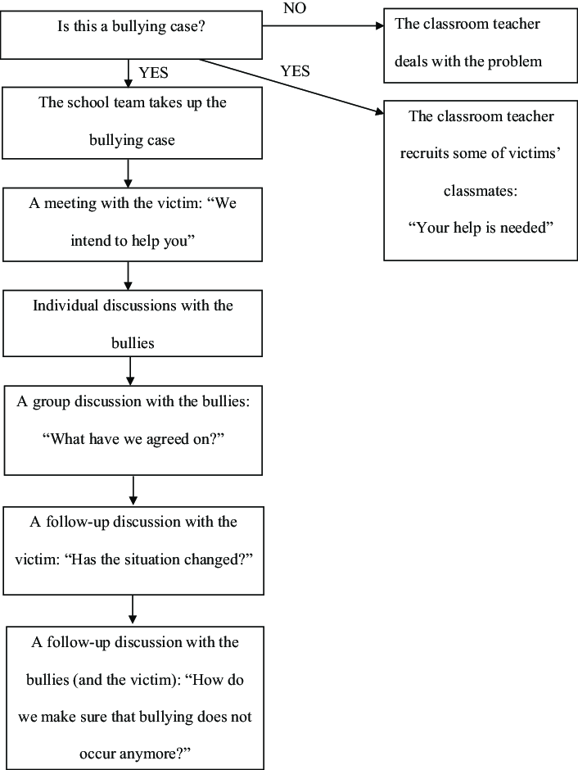

Alexandra Sevko  Ph.D., FIBMSc | Headteacher
Iryna Shymkova | Deputy Headteacher, Designated Safeguarding Lead
Valentyna Bondarenko | Financial director

This policy will be reviewed at least annually, and following any concerns and/or updates to national/local guidance or procedures based on the recommendations at https://www.gov.uk/education/school-bullying. Note: When amending this template to reflect individual practice, school will look into the DfE research into anti-bullying practices: www.gov.uk/government/publications/approaches-to-preventing-and-tackling-bullying
The Anti-Bullying Policy is revised on 26/09/2025 with improved clarity, conciseness. Policy updated with explicit references to KCSIE 2025 and updated online safety language. The cross-references to the Safeguarding and Behaviour policies were added, the language was slightly modernised, and sanctions/rewards were tightened up to improve practical use for a Saturday school format.

